**1**

**a)** Are the following substances chemically pure or classed as mixtures? Put a tick in the correct box. (7)

|  |  |  |
| --- | --- | --- |
| **Substance** | **Pure** | **Mixture** |
| Air |  |  |
| Sea water |  |  |
| Glucose |  |  |
| Bromine |  |  |
| Distilled water |  |  |
| Milk |  |  |
| Sodium hydroxide solution |  |  |

**b)** Are the following substances elements or compounds? Put a tick in the correct box. (5)

|  |  |  |
| --- | --- | --- |
| **Substance** | **Element** | **Compound** |
| Sodium (Na) |  |  |
| Water (H2O) |  |  |
| Helium (He2) |  |  |
| Bromine (Br2) |  |  |
| Glucose (C6H12O6) |  |  |

c) Alloys, fuels and paints are all examples of formulations. Explain briefly what a formulation is. (2)

**2**

**a)** The diagram below shows a chromatography experiment used for separating inks.



From the diagram what are the following pointing to:

A = ____________________________________ (1)

B = ____________________________________ (1)

C = ____________________________________ (1)

**b)** Why is the start line drawn in pencil? (1)

**c)** What component is the mobile phase? (1)

**d)** What component is the stationary phase? (1)

**e)** After several minutes, the dots have moved up the paper.

**i)** Why does this happen? (2)

**ii)** Why do some move further than others? (2)

**iii)** Calculate the Rf values for the two dyes shown in the diagram below.

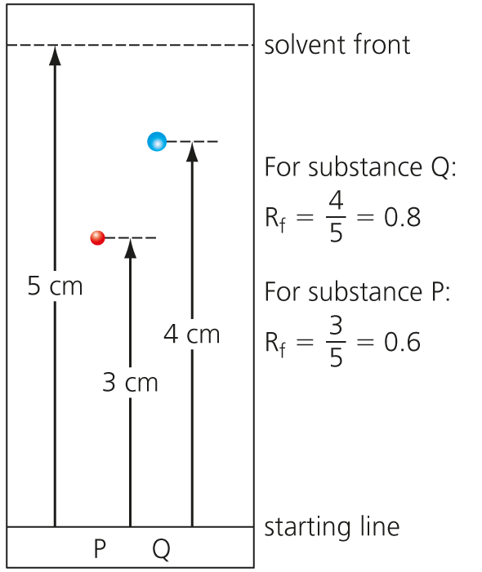

Rf for P ___________ (1)

Rf for Q __________ (1)

**3**

**a)** Below are various tests used to detect different gases.

|  |  |  |
| --- | --- | --- |
|  | **Test** | **Result** |
| A | Glowing splint | Relights |
| B | Lit splint | Squeaky pop |
| C | Bubble gas through limewater | Goes cloudy |
| D | Hold damp blue litmus paper in gas | Goes white |

Give the correct letter of the test which is used to detect:

**i)** Hydrogen ________ (1)

**ii)** Chlorine ________ (1)

**iii)** Oxygen _______ (1)

**iv)** Carbon dioxide _________ (1)

**b)** Fill in the gaps in the table below for results of flame testing: (4)

|  |  |
| --- | --- |
| **Metal** | **Colour** |
| Sodium |  |
|  | Green |
| Lithium |  |
|  | Lilac |

**c)** Briefly state how a flame test is carried out. (2)

**4** Sodium hydroxide can be used to identify Fe2+ ions.

**a)** Write the balanced chemical equation for the reaction that occurs with sodium hydroxide and iron II chloride. (3)

**b)** What is the colour of the precipitate formed? (1)

**c)** This reaction can be expressed in an *ionic* equation. Complete and balance the equation. (2)

___Fe2+(aq) + ____(OH)−(aq) → _________________

**5**

**a)** A student found four containers with no labels as the labels had fallen off the containers. The labels read: magnesium chloride, sodium chloride, magnesium sulfate, sodium sulfate.

Explain, by using *chemical tests*, how the student could distinguish between the four chemicals. (6)

**b)** What advantage has flame emission spectroscopy over a simple flame test? (2)

Total = 50

**1**

**a)**

|  |  |  |
| --- | --- | --- |
| **Substance** | **Pure** | **Mixture** |
| Air |  | 🗸 |
| Sea water |  | 🗸 |
| Glucose | 🗸 |  |
| Bromine | 🗸 |  |
| Distilled water | 🗸 |  |
| Milk |  | 🗸 |
| Sodium hydroxide solution |  | 🗸 |

(7)

**b)**

|  |  |  |
| --- | --- | --- |
| **Substance** | **Element** | **Compound** |
| Sodium (Na) | 🗸 |  |
| Water (H2O) |  | 🗸 |
| Helium (He) | 🗸 |  |
| Bromine (Br2) | 🗸 |  |
| Glucose (C6H12O6) |  | 🗸 |

(5)

**c)** A formulation is a **mixture** that has been **designed as a useful product**. (2)

**2**

**a)** A = (chromatography) paper (1); B = beaker/jar/container (1); C = water/solvent (1)

**b)** Ink would ‘run’/smudge/pencil doesn’t. (1)

**c)** Solvent (1)

**d)** Paper (1)

**e)**

**i)** Substances that have a stronger attraction to the solvent move quickly and travel a long way up the paper. Substances that have a stronger attraction to the paper move slowly and only travel a short distance up the paper. (2)

**ii)** Some have **stronger attraction** to the **solvent** than the paper. (2)

**iii)** Rf for P =  = 0.6; Rf for Q =  = 0.8 (2)

**3**

**a)**

**i)** B (1)

**ii)** D (1)

**iii)** A (1)

**iv)** C (1)

**b)**

|  |  |
| --- | --- |
| **Metal** | **Colour** |
| Sodium | **Yellow** |
| **Copper** | Green |
| Lithium | **Crimson** |
| **Potassium** | Lilac |

(4)

**c)** Dip nichrome wire/splint into acid then into sample then into flame. (2)

**4**

**a)** 2NaOH + FeCl2 → Fe(OH)2 + 2NaCl (LHS = 1, RHS = 1, balance = 1)

**b)** Green (1)

**c)** Fe2+(aq) + **2**(OH)**-** (aq) → Fe(OH)2(s) (balance = 1 mark, (s) = 1)

**5**

**a)**

|  |  |
| --- | --- |
| **Marks** |  |
| 6–5 | At least three different points well expressed |
| 4–3 | A couple of points mentioned |
| 2–1 | Not much detail |

* Flame test
* Na = yellow flame,
* Mg = no colour
* Add a few drops nitric acid.
* Add silver nitrate.
* White precipitate = chloride ions
* Add barium chloride.
* White precipitate = sulfate ion

**b)** Flame emission spectra can measure **concentrations** of ions in **solutions**. (2)

Total = 50